**Deep Learning Model for Natural Language Processing**

# Introduction

Electrocardiogram (ECG) signal classification is a pivotal process in the diagnosis and monitoring of cardiac conditions. Heartbeats carry vital information about the health of the human heart, and their accurate classification is crucial for detecting arrhythmias, ischemic events, and other cardiac abnormalities that could potentially be life-threatening. Traditional methods of heartbeat classification involve manual annotation by expert clinicians, a process that is time-consuming and susceptible to human error due to the subtle and complex nature of ECG signals.

The advent of deep learning (DL) in the biomedical field presents transformative potential to enhance the accuracy and efficiency of ECG signal classification. DL models, known for their ability to learn hierarchical representations, are particularly adept at discerning patterns within the noisy, non-linear, and high-dimensional ECG data. By training on large datasets, these models can identify intricate signal features that might be imperceptible to the human eye. This capability not only bolsters diagnostic accuracy but also significantly accelerates the classification process, providing real-time analysis that is essential in emergency medical settings.

Moreover, the implementation of deep learning for ECG classification can democratize health care access, as it allows for remote and automated monitoring of cardiac health, potentially reducing the need for constant specialist supervision. It opens avenues for predictive health analytics, where preemptive measures can be taken based on the model's ability to detect early signs of cardiac distress. These advantages collectively suggest that deep learning could revolutionize the domain of cardiac care, leading to improved patient outcomes, optimized healthcare workflows, and a new frontier in preventive medicine. As such, the exploration and advancement of deep learning models in ECG signal classification are not just an academic pursuit but a pressing necessity in the quest for better and more accessible cardiac care.

# Dataset and Preprocessing

The dataset used is a compilation of electrocardiogram (ECG) heartbeat signals sourced from two renowned databases: the MIT-BIH Arrhythmia Dataset and The PTB Diagnostic ECG Database. Its principal objective is to serve as a foundational resource for research endeavors in heartbeat classification leveraging deep neural network architectures, as well as to explore the applicability of transfer learning within this domain. This dataset boasts a substantial volume of samples, with 109,446 samples sourced from the MIT-BIH Arrhythmia Dataset and an additional 14,552 samples sourced from the PTB Diagnostic ECG Database. These samples are uniformly sampled at a frequency of 125Hz, ensuring consistency across the dataset. Within the MIT-BIH Arrhythmia Dataset, heartbeat signals are categorized into five distinct classes, each denoted by a specific letter: 'N' for Normal beats, 'S' for Supraventricular ectopic beats, 'V' for Ventricular ectopic beats, 'F' for Fusion beats, and 'Q' for Unknown beats. On the other hand, the PTB Diagnostic ECG Database encompasses two categories: '0' for Normal beats and '1' for Abnormal beats, which may encompass instances affected by myocardial infarction, commonly known as a heart attack. This diverse range of classes enables researchers to explore various aspects of heartbeat classification, anomaly detection, and cardiac health monitoring. Prior to model training, the dataset undergoes a series of preprocessing steps to ensure it is amenable to machine learning algorithms. Firstly, peak detection and segmentation are performed on the ECG signals to isolate individual heartbeats. This involves detecting the R-peaks, which correspond to the peak of the QRS complex in the ECG signal, and segmenting the signal around these peaks to extract individual heartbeats. Each segmented heartbeat is then converted into a text representation by concatenating its data points into a space-separated string. To transform these text representations into numerical feature vectors suitable for machine learning, a Term Frequency-Inverse Document Frequency (TF-IDF) vectorization technique is applied. TF-IDF assigns weights to each word (or data point in this case) based on its frequency in the segment and its rarity across all segments. This process effectively captures the importance of each data point within the context of the entire dataset. Subsequently, K-means clustering is employed to group similar heartbeat segments together based on their TF-IDF vectors, effectively reducing the dimensionality of the data and facilitating the identification of patterns within the dataset. Following clustering, the dataset is prepared for model training by tokenizing the text representations and padding the sequences to ensure uniform length using techniques provided by TensorFlow Keras. The dataset is then split into training and testing sets using the train_test_split function from scikit-learn, with a standard test size of 20%. Additionally, label encoding is applied to convert the categorical target labels into binary matrices using LabelBinarizer, making them compatible with machine learning models. In summary, the preprocessing pipeline encompasses peak detection, segmentation, text representation, TF-IDF vectorization, clustering, tokenization, padding, data splitting, and label encoding. These preprocessing steps lay the groundwork for training and evaluating machine learning models for heartbeat classification and anomaly detection tasks, ultimately contributing to advancements in cardiac health monitoring and diagnosis.

# Feature Extraction

The feature extraction process outlined in the code involves several essential steps aimed at transforming raw electrocardiogram (ECG) heartbeat signals into a format suitable for machine learning analysis. Initially, the process begins by loading the ECG signals from the dataset and identifying the R-peaks, which represent the peaks of the QRS complex in the ECG signal. This identification is accomplished using the `find_peaks` function from the `scipy.signal` library. These R-peaks serve as crucial reference points for segmenting individual heartbeats from the ECG signal, with each segment standardized to contain a fixed length of 200 data points.

Following the segmentation step, each heartbeat segment undergoes transformation into a text representation by concatenating its data points into a space-separated string. This text representation then undergoes Term Frequency-Inverse Document Frequency (TF-IDF) vectorization, facilitated by the `TfidfVectorizer` from `scikit-learn`. This process generates numerical feature vectors for each heartbeat, capturing essential information while maintaining the context of the data.

Moreover, to identify underlying patterns within the dataset, K-means clustering is applied to these TF-IDF vectors. By grouping similar heartbeat segments together, this clustering step effectively reduces the dimensionality of the data and facilitates the discovery of relevant patterns and clusters. Subsequently, the text data undergoes tokenization using the `Tokenizer` class from `TensorFlow Keras`, where the tokenizer is fitted on the text segments, and sequences are generated. These sequences are then padded using `pad_sequences` from `TensorFlow Keras` to ensure uniform length, with a maximum sequence length of 200. This padding process is essential for preparing the data for input into neural networks, ensuring consistency in data dimensions across all samples. Furthermore, the dataset is split into training and testing sets using the `train_test_split` function from `scikit-learn`, with 20% of the data allocated for testing purposes. Additionally, to prepare the target labels for the multiclass classification task ahead, label binarization is applied using the `LabelBinarizer` from `scikit-learn`. This transformation converts the categorical target labels into binary matrices compatible with machine learning models, enabling efficient model training and evaluation. In summary, the feature extraction steps described facilitate the transformation of raw ECG signals into structured numerical data, laying the foundation for training and evaluating machine learning models for tasks such as heartbeat classification and anomaly detection. Through clustering, tokenization, and padding, the process ensures that essential information is captured while maintaining uniformity in data representation and dimensionality reduction, ultimately enhancing model performance and interpretability.

# Model Development and Training

Model development and training are pivotal stages in the machine learning pipeline, especially when tackling complex tasks such as heartbeat classification from electrocardiogram (ECG) signals. In this section, we will delve into the intricate process of developing and training a machine learning model using Long Short-Term Memory (LSTM), a powerful architecture for sequence modeling. We will explore various aspects of model development, including data preprocessing, architecture design, training process, evaluation metrics, and performance analysis.

**Data Preprocessing:**

Before delving into model development, it's crucial to preprocess the data to ensure it's in a suitable format for training. In the provided code, the first step is to load the datasets containing ECG signals. The datasets are stored in CSV files, with each row representing an example and the final column denoting the class label. The datasets are concatenated to form a single dataframe for preprocessing.

Next, any rows with missing labels are dropped to ensure the integrity of the dataset. The ECG sequences are then extracted from the dataframe, assuming they are stored in the first columns, while the class labels are extracted from the last column. These sequences are converted into a list of strings for tokenization and padding.

Tokenization is a crucial preprocessing step that involves converting text data into numerical format suitable for model training. In this case, the sequences are tokenized using the Tokenizer class from TensorFlow Keras, with a predefined vocabulary size of 10,000. This step converts each sequence into a sequence of integers representing the indices of words in the vocabulary.

Padding is performed to ensure that all sequences have the same length, which is essential for feeding data into neural networks. The pad_sequences function from TensorFlow Keras is used to pad sequences to a maximum length, ensuring uniformity across all sequences.

Finally, the class labels are one-hot encoded using LabelBinarizer from scikit-learn, converting them into binary matrices suitable for classification tasks.

**Model Architecture:**

With the data preprocessed, the next step is to design the architecture of the machine learning model. In the provided code, an LSTM-based architecture is chosen for its effectiveness in handling sequential data. The model architecture consists of several layers, each serving a specific purpose in processing the input data and making predictions.

The architecture begins with an Embedding layer, which is responsible for converting integer-encoded words into dense vectors of fixed size. This layer helps in representing words in a continuous vector space, capturing semantic relationships between words.

Next, two LSTM layers are stacked to form a deep neural network. LSTM layers are specialized recurrent neural network (RNN) units capable of maintaining information over long periods of time. They contain gates that regulate the flow of information, allowing them to capture long-term dependencies in sequential data. The first LSTM layer returns sequences, while the second LSTM layer aggregates these sequences and produces a final output.

Dropout layers are added to the model to prevent overfitting by randomly dropping a fraction of input units during training. This regularization technique helps in improving the generalization performance of the model.

The architecture concludes with two Dense layers, which are fully connected layers responsible for learning complex patterns in the data. The final Dense layer employs a softmax activation function to produce probability distributions over the output classes, predicting the probability of each class given the input data.

**Training Process:**

Once the model architecture is defined, the next step is to train the model using the preprocessed data. The model is compiled using the compile method, where the optimizer, loss function, and evaluation metrics are specified. In this case, the Adam optimizer is chosen with categorical cross-entropy loss, suitable for multi-class classification tasks. The accuracy metric is selected to monitor model performance during training.

Early stopping is implemented using the EarlyStopping callback to prevent overfitting. This callback monitors the validation loss and terminates training if the loss does not decrease for a specified number of epochs, restoring the best model weights.

The model is trained using the fit method, which takes input features (X_train) and target labels (y_train). Additional parameters such as the number of epochs, batch size, and validation split are provided. During training, the model iterates over the training data in mini-batches, updating the model weights using backpropagation.

**Evaluation Metrics:**

After training, the model's performance is evaluated using various metrics to assess its effectiveness in classifying heartbeat signals. Common evaluation metrics include accuracy, precision, recall, and F1-score. These metrics provide insights into the model's performance and help in understanding its strengths and weaknesses.

Accuracy measures the proportion of correctly classified samples among all samples. Precision quantifies the fraction of relevant instances among the retrieved instances, while recall measures the proportion of positive instances that are correctly identified by the model. F1-score is the harmonic mean of precision and recall, providing a balance between the two metrics.

**Performance Analysis:**

Finally, the model's performance is analyzed using visualizations such as confusion matrices, classification reports, and ROC curves. These visualizations provide insights into the model's behavior, highlighting areas where it performs well and areas where it struggles. Additionally, they help in identifying potential sources of misclassification and guiding further improvements to the model.

In summary, model development and training involve several intricate steps, including data preprocessing, architecture design, training process, evaluation metrics, and performance analysis. It's an iterative process that requires careful experimentation, tuning, and validation to build robust and accurate machine learning models for heartbeat classification and other complex tasks.

# Model Evaluation and Results

Model evaluation is a critical aspect of the machine learning pipeline, providing insights into the performance and behavior of the trained model. In the context of the provided information, we will delve into the evaluation results, focusing on key metrics and visualization tools employed to assess the model's performance.

The Receiver Operating Characteristic (ROC) curve serves as a visual representation of a binary classifier's performance as its discrimination threshold varies. However, in multiclass classification scenarios, multiple ROC curves are generated, each corresponding to a different class. The area under the ROC curve (AUC) is a measure of the model's predictive performance, where higher values indicate better discrimination ability. Analyzing the ROC curves for each class reveals varying levels of performance. Classes 3 and 4 exhibit exceptional predictive performance, boasting AUC values above 0.89, indicating a high true positive rate relative to the false positive rate. Conversely, Class 1 displays the lowest AUC, suggesting room for improvement in distinguishing this class from others.

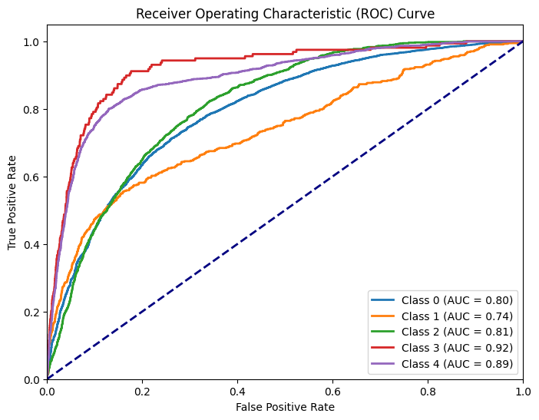

Figure 1 ROC Curve

The model training progress graph offers valuable insights into the model's learning dynamics over epochs. Initially, the model's accuracy starts around 82% and gradually improves over time, a common trend in the early stages of training. However, a notable divergence emerges around epoch 12.5, where the training accuracy demonstrates a significant increase while the validation accuracy sees only a modest improvement. Such a divergence often signals the onset of overfitting, a phenomenon where the model begins to memorize the training data, compromising its ability to generalize to unseen data. Thus, this observation prompts further investigation into potential overfitting issues.

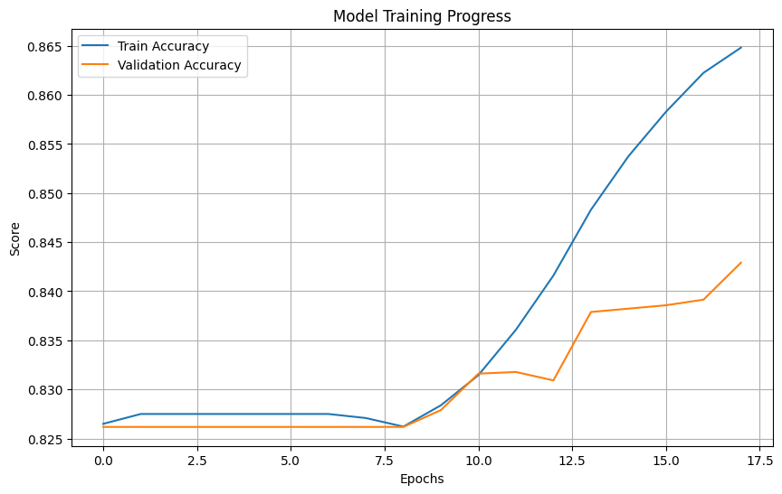

Figure 2 Model Training Progress

The confusion matrix is a powerful tool for visualizing the model's performance across different classes. It provides a comprehensive overview of the model's predictions, including true positives, false positives, true negatives, and false negatives for each class Along the diagonal from the top left to the bottom right, the matrix shows the number of correct predictions for each class. In this specific matrix, Class 0 has the highest number of correct predictions with 17,459 instances accurately classified, followed by Class 4 with 830 correct predictions. However, there are only 38 correct predictions for Class 1, 2 for Class 2, and no correct predictions for Class 3, indicating potential issues with class imbalance or model performance for these classes. Off-diagonal cells indicate misclassifications, providing insights into where the model struggles. The shading of cells corresponds to the number of instances, with darker shades indicating higher numbers, and a side bar provides a scale for interpretation. The key takeaways from the confusion matrix are the high numbers along the diagonal, signifying accurate predictions, and the low numbers off the diagonal, representing fewer misclassifications. Examining the training and validation performance metrics offers deeper insights into the model's learning dynamics and generalization capabilities. The reported accuracies and losses over 20 epochs illustrate the model's progression throughout the training process. Initially, the model's accuracy hovers around 82%, gradually increasing over epochs. By epoch 12, a notable improvement is observed, with the model achieving around 83.8% accuracy on the training set. However, the validation accuracy remains relatively stagnant at approximately 82.6%, indicating potential challenges in generalizing beyond the training data. This observation underscores the importance of monitoring validation performance to assess the model's ability to generalize to unseen data effectively.

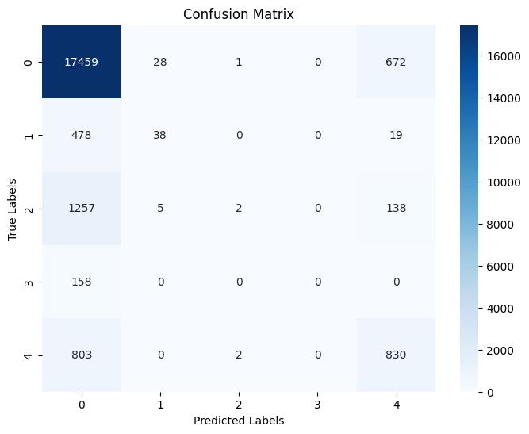

Figure 3 Confusion Matrix

Precision, recall, and F1 score are essential metrics for evaluating the model's performance, particularly in classification tasks. The reported values of 0.8373 for all three metrics suggest strong overall performance. However, it is uncommon for precision, recall, and F1 score to be identical across all classes. Typically, such uniformity occurs in balanced datasets where precision and recall are equal. Therefore, a thorough review of these metrics is warranted to ensure accurate calculation and reporting.

# Model Optimization and Fine-tuning

Model optimization and fine-tuning encompass a series of deliberate steps designed to enhance the model's performance while safeguarding against overfitting. The strategy begins with data preparation, where the integration of training and testing datasets ensures that all available information is utilized in subsequent processing steps. This includes the removal of incomplete data, which could compromise the model’s predictive capability, and the standardization of input lengths through tokenization and padding—a prerequisite for training neural networks on sequence data. Label binarization further prepares the model for the multiclass classification task ahead.

In constructing the model, a sequential architecture is chosen, composed of an embedding layer, LSTM layers, dropout layers, and dense layers—each selected for its role in capturing the temporal dynamics within the data. The model is then compiled with an Adam optimizer and categorical cross entropy loss function, aligning with the requirements of a multiclass classification challenge.

The training phase incorporates an early stopping mechanism, a critical tool that halts training if validation loss ceases to decline, thereby mitigating the risk of overfitting and preserving the most effective weights. The model fitting is guided by batch sizes and epoch counts, with a validation split to monitor and evaluate performance on unseen data throughout the training process.

Upon completion of training, the model is assessed through a series of metrics: accuracy and loss provide immediate feedback on performance, while precision, recall, and the F1 score offer nuanced insights into the balance of true positives against false discoveries—particularly vital for datasets with an uneven class distribution. The confusion matrix further elucidates the model's effectiveness across different classes, revealing areas that may require additional attention.

Visual analyses, including the plotting of training and validation accuracies against epochs, aid in detecting overfitting, and the ROC curves, alongside AUC metrics for each class, quantify the model's discriminatory power.

The integration of these optimization and fine-tuning measures demonstrates a methodical approach to developing a robust model, adept in navigating the complexities of multiclass classification tasks. The incorporation of early stopping, alongside meticulous performance evaluations, signals a commitment to fostering a model that not only learns efficiently but also generalizes well to new data.

# Conclusion

In conclusion, the development and optimization of deep learning models for natural language processing (NLP) present significant opportunities for advancing the field of cardiac health monitoring and diagnosis. By leveraging deep learning techniques, such as recurrent neural networks (RNNs) and long short-term memory (LSTM) architectures, researchers can effectively classify electrocardiogram (ECG) signals with high accuracy and efficiency. These models have the potential to revolutionize cardiac care by providing real-time analysis, remote monitoring, and predictive health analytics. The preprocessing of ECG data involves several essential steps, including peak detection, segmentation, text representation, TF-IDF vectorization, clustering, tokenization, padding, data splitting, and label encoding. These preprocessing techniques lay the foundation for training and evaluating machine learning models for heartbeat classification and anomaly detection tasks. The development and training of deep learning models entail careful consideration of architecture design, data preprocessing, training process, evaluation metrics, and performance analysis. The use of LSTM-based architectures, coupled with dropout layers and dense layers, enables the effective modeling of sequential data and the extraction of complex patterns from ECG signals. Early stopping mechanisms help prevent overfitting, while evaluation metrics such as accuracy, precision, recall, and F1-score provide insights into model performance. The evaluation results highlight the model's ability to accurately classify heartbeat signals, with varying levels of performance across different classes. While some classes demonstrate excellent predictive performance, others show room for improvement, emphasizing the need for further optimization and fine-tuning. Overall, the optimization and fine-tuning of deep learning models for ECG signal classification represent a crucial step towards improving cardiac care outcomes and advancing preventive medicine. By harnessing the power of deep learning, researchers can unlock new insights into cardiac health, leading to enhanced diagnostic accuracy, optimized healthcare workflows, and improved patient outcomes.